|  |  |
| --- | --- |
|  | **MGM's College of Engineering and Technology Kamothe,**  **Navi Mumbai - 410 209** |

Department of Electronics and telecommunication Engineering

**SKEP WEEK 1**

**REPORT**

**DATED- 27/07/2018**

**Time: 4:00 PM**

**Address: MGM's College of Engineering and Technology Kamothe, Navi Mumbai.**

**ABOUT SKEP: - Skill and Knowledge Enhancement Program**

Skill and Knowledge Enhancement Program (SKEP). SKEP organizes talks, tutorials and distinguished lectures with an intention to reach out to students, faculties and industry professionals. SKEP programmes are an exercise in life-long learning and are offered for the continuing education and skill up gradation of professionals. In addition, this program seeks to motivate and inspire the young student community and endow them with a rare insight into what the industry has to offer and its expectations, thus helping them ease their entry into corporate life. Main goals of SKEP include professional skills development, imparting technical expertise to develop viable applications, disseminating useful knowledge from current fields of interest to the beneficiaries and inculcating technical and logical thinking among the student community. SKEP programmes are conducted by invited experts on the state-of-the-art topics from among the research, academic and industrial areas. The intended audience is students, faculty, IEEE members and other interested persons from research, industry and academic institutions.

As part of activity of SKEP, the department of EXTC Engineering organized a guest lecture inviting **Dr. Sanjay S Pawar** **Principal UMIT,SNDT** on 27th July 2018 at Sir Visvesarya Seminar hall. Students of second year , Third Year , Final Year EXTC attended the lecture. In his address, **Dr. Sanjay S Pawar** Discussed on the topic “**CHALLENGES & ISSUES IN 5G**”.

**ABOUT The Department :- Electronics and telecommunication Engineering**

**Vision -** To produce world class Technocrats, Scientists & Entrepreneurs with new ideas & innovations to meet cost effective industry expectations for all sections of society.

**Mission –**

1.To develop & deliver quality academic programs in emerging & innovative field of Engineering to empower the students to meet Industry Standards.

2. To motivate students to develop innovative solutions for betterment of society.

3. To Create Centre of Excellence by establishing the Incubation Centers to meet global research challenges.

We Started with Introductory Speech by our Respected **HOD EXTC Dr Indra Vijay Singh** & then inviting our Guest **Dr. Sanjay S Pawar** for the talk.

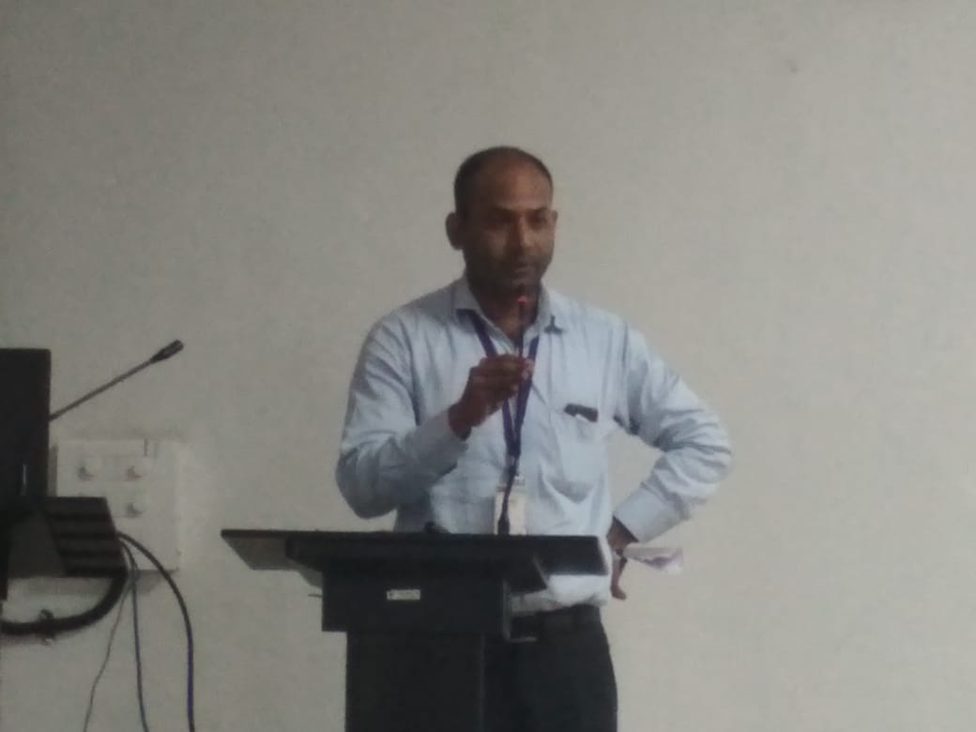 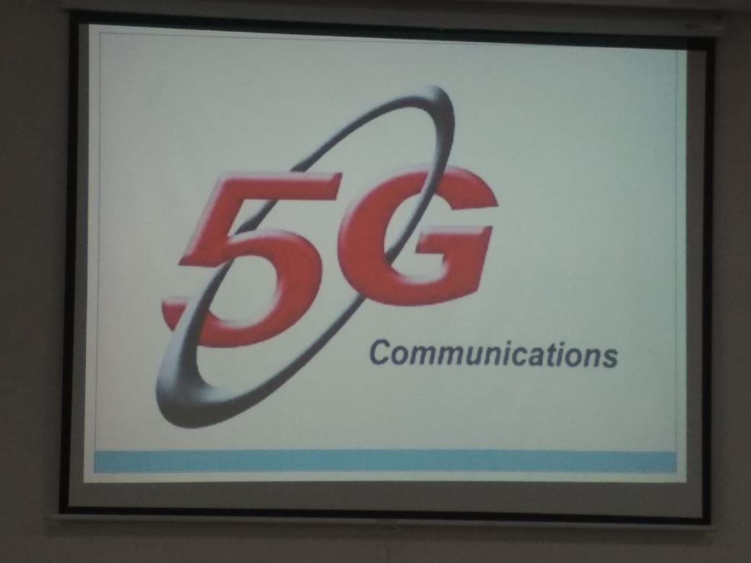

Fig 1 - Head of the department giving introductory speech. Fig 2 – Glimpse of 5G Communications

In his lecture  **Dr. Sanjay S. Pawar** discussed the Following :-

1. Comparison between 3g & 4g and the advancement of upcoming 5g technology.

* Speed.
* Frequency
* Bandwidth

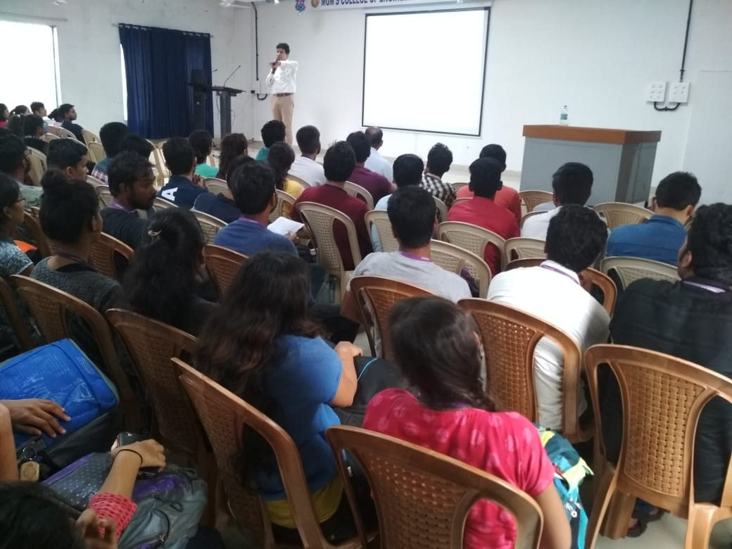 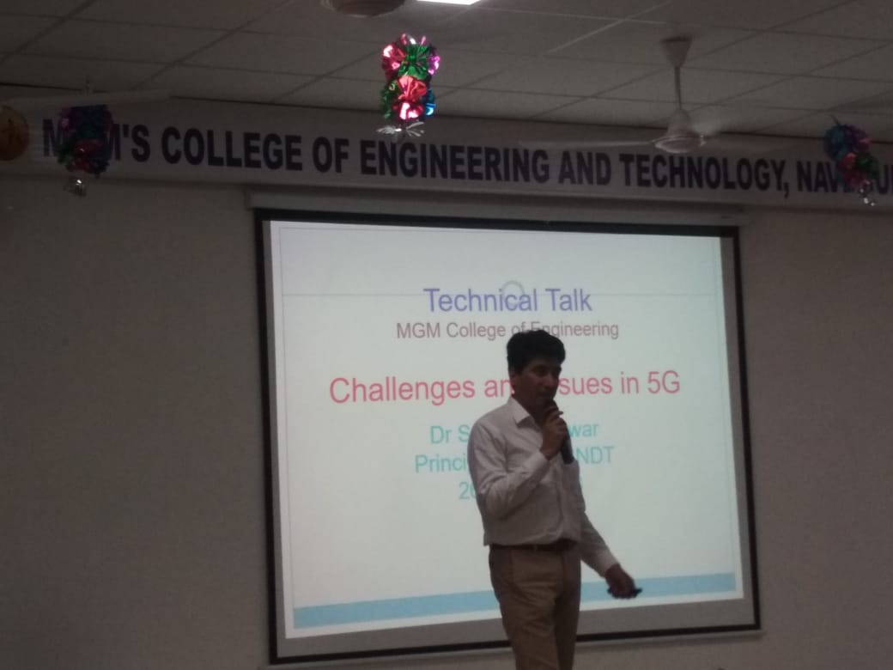

Fig 3 & 4 – **Dr. Sanjay S. Pawar** addressing the Students

1. Problem occurring in network capacity.
2. Crucial Challenges.

* Smart Spectrum Use.
* High Energy consumption.
* High DR.

1. Holographic Projections
2. 5G Architecture Diagram.

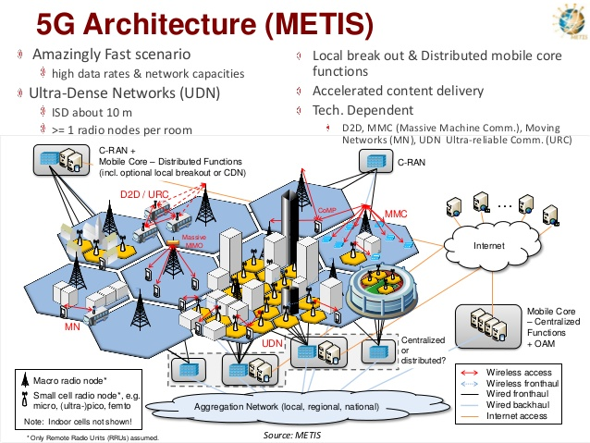

Fig 5 – Architecture of 5G.

1. Future of 5G. ( Streaming of TOKYO Olympics 2020 from 5G ).

At the end of the lecture, few students asked questions regarding the topic and were very satisfied with the answer from **Dr.** **Pawar.** He concluded his talk by insisting the students and faculty to plan for more of vertical Research, Projects Based on developing challenge free 5G rather than going for horizontal research on it.

We thank The Management, The Principal, The HOD, Guest speaker, Participants and supporting faculty’s for their support.

Attendance – 56 Students , 10 Faculty members.

MGMCET NAVI MUMBAI

STB-37121

MUKESH VERMA NEDA KHAN Dr Indra Vijay Singh

BRANCH CHAIRPERSON BRANCH COUNSELOR Head of Department, EXTC

OJAS BALSOTRA

BRANCH VICE-CHAIRPERSON